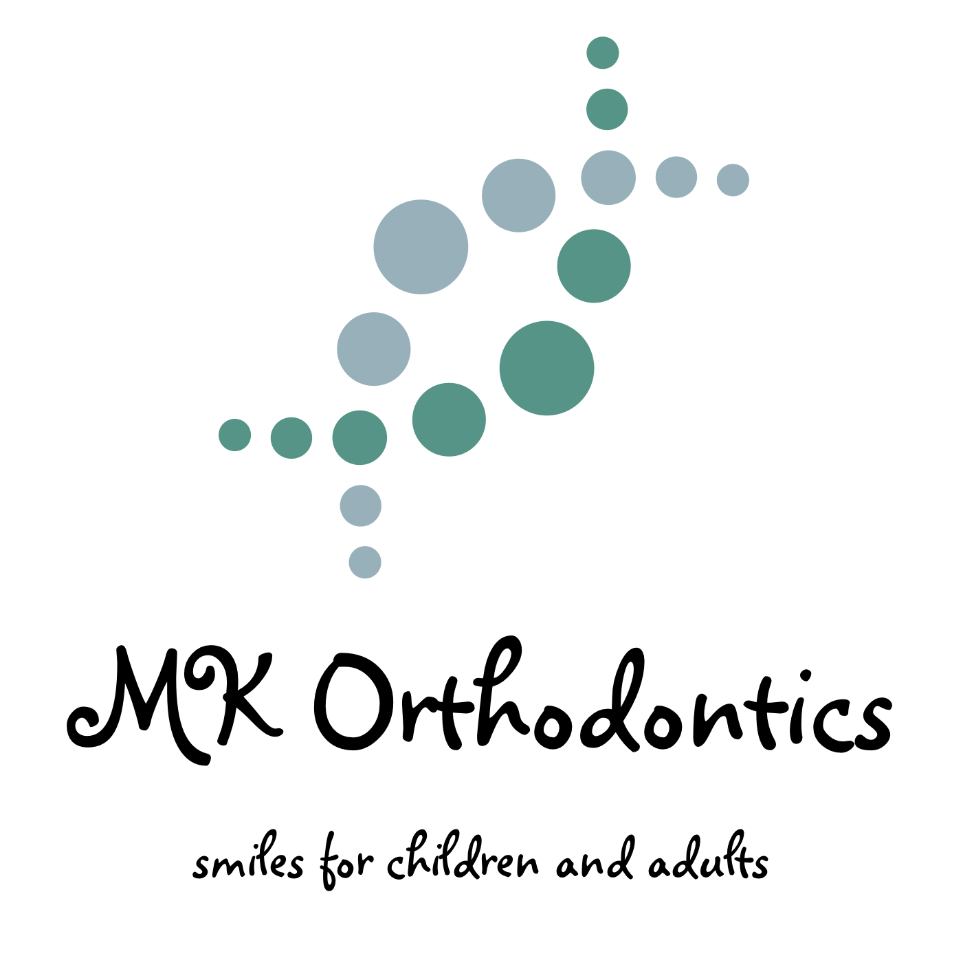
REQUEST FOR RELEASE OF RECORDS

Date : ______________

I, (patient or parent’s (if patient is under 18 years of age) name) ___________________________________________ hereby request and give my permission to Dr. Kleinlerer to provide
Dr. _________________________________________________________________________
Address: ____________________________________________________________________
City: ______________________ State: __________ Zip/Postal Code: _____________
any and all information which he/she may request with respect to the orthodontic care of (patient) ________________________________________________.
Such records may include medical care and treatment, illness or injury, dental history, medical history, consultation, prescriptions, x-rays, models and copies of all dental records and medical records.
I agree to pay the cost of duplicating any records. A photocopy of this release will be as effective and valid as the original.

Signed: ________________________________ Date Signed: ___________________
Phone: __________________________________
Address: ________________________________________________________________

